

**Restaurant Analysis**

**Analysis contributors**

**Moaz Ahmed**

**Israa Mohamed**

**Amr Jamal**

**Submitted to**

**Dr.Sarah Besheer**

**Source code :**Source from kaggle

**Cleaning Stage:**

· Importing Libraries

· Loading Data

· Initial Data Inspection

· Inspecting Data Columns

· Standardizing Date Format

· Displaying Updated Date Values

· Inspecting Data Shape

· Getting DataFrame Information

· Descriptive Statistics (data.describe())

· Counting Unique Values

· Checking for Missing Values

· Identifying Duplicate Entries

· Dropping Unnecessary Column["order_id", "transaction_amount"]

· Show Counting value for [item_name , item_type , item_price , quantity , transaction_type , received_by , time_of_sale ]

· Filling Missing Values in transaction_type with the most frequent transaction type identified

· Calculate total cost

· dates got cleaned

· also we got rid of redundant columns.

**Objectives Stage:**

* **What is the Distribution of Item Types?**
* **Which Fast Food Items Have the Highest Quantity sold ?**
* **Which Beverage Items Have the Highest Quantity Sold?**
* **What is Most selling item ?**
* **When were the highest total costs recorded?**
* **Distribution of Total Cost?**
* **What is the Distribution of item type ?**
* **Which transaction type is used more frequently?**
* **At what time of day are items sold the most frequently?**

**Analysis Stage:**

* **Question 1:**
  + What is the frequency of the fast-food and beverages?
  + The below figure answers the question.

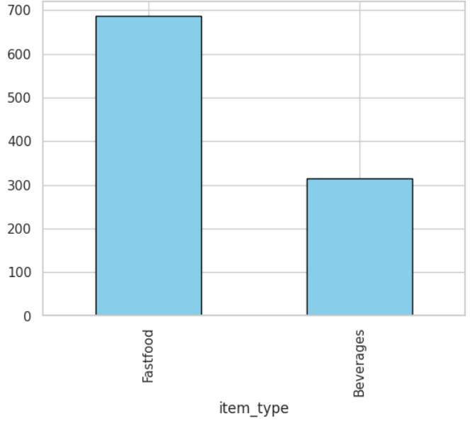

* **Question 2**
  + Within the beverages we analyzed the frequency to route our decisions.

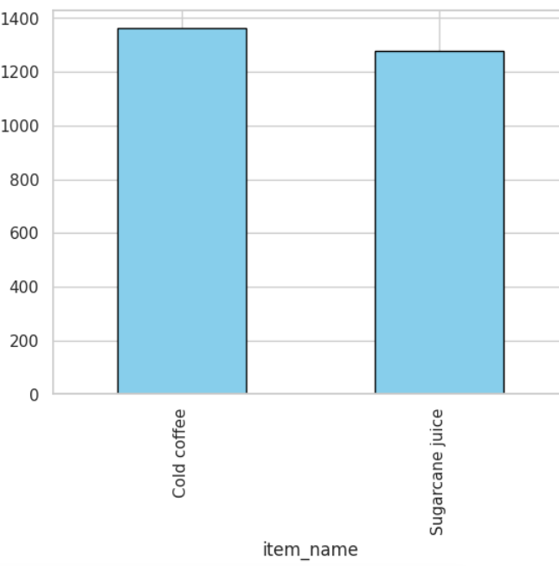

* After analyzing both quantities we also need cost analysis wich can be summarized in this bar chart   
  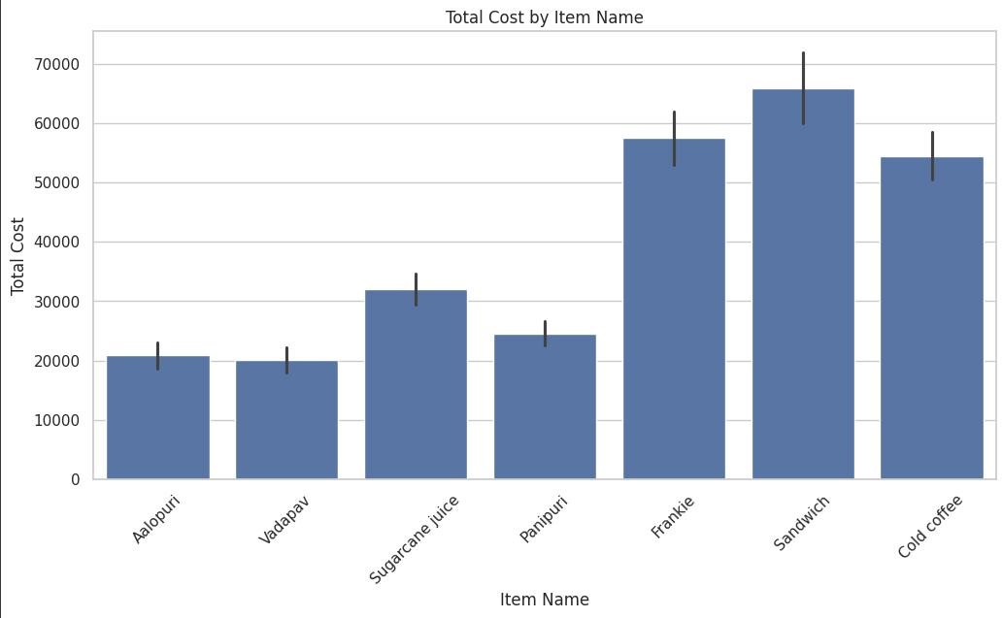

It’s clearly sandwich and frankie and cold coffee is making the most of revenue but also panipury is frequently buyed so we need to consider it in the sales

* After the analysis we can see that we want sandwich, frankie and panipuri in the sale.
* For the beverages we have the cold coffee and the sugarcane to put in the sale
* We also analyzed the date and the purchase and the total cost  
  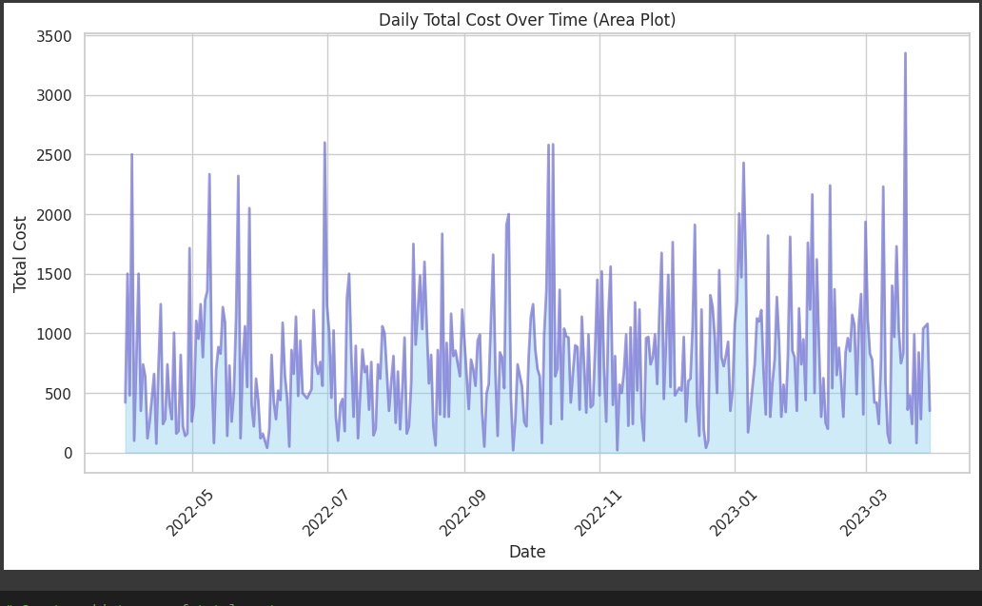
* Also most of the purchase comes from in place purchase  
  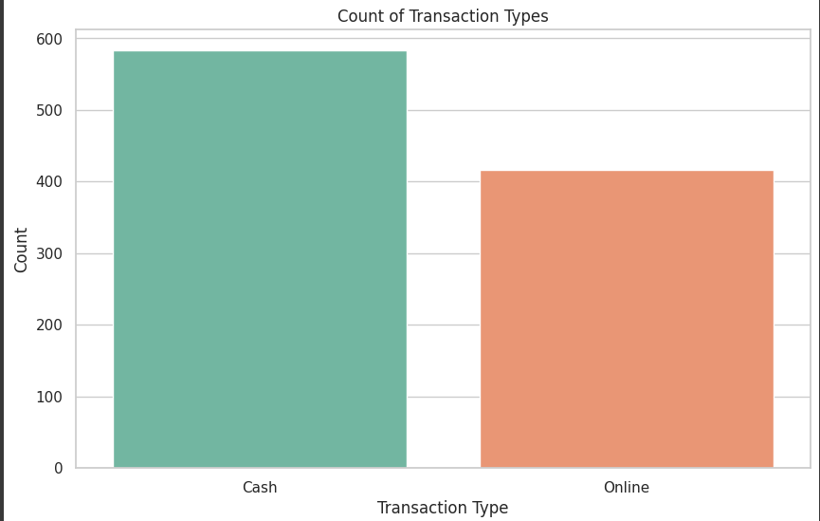

### Analysis of Total Costs by Item Type

we analyze total costs based on item types:

1. Calculate Costs: We sum the total costs for each item type.
2. Create Pie Chart: A pie chart visualizes how much each item type contributes to the total costs.
3. Understand Results: Each slice of the pie represents the percentage of total costs for that item type.
4. Business Decisions: This analysis helps decide which item types to promote or focus on.
5. Next Steps: Further exploration could include looking at trends over time or customer preferences.

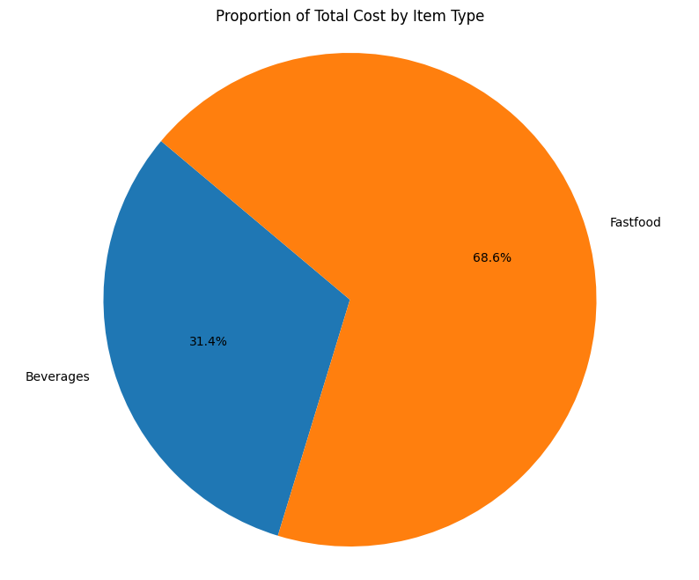

### Analysis of Total Cost Distribution

In this code, we look at how total costs are distributed:

1. Create Histogram: We make a histogram to show how often different total cost values occur.
2. Set Parameters: The histogram uses 30 bins and includes a smooth curve to highlight trends.
3. Interpret Results: This helps us see common price ranges and any unusual values.
4. Insights: Understanding the distribution can reveal customer spending habits.
5. Next Steps: We could compare this distribution with other item types or transaction types.

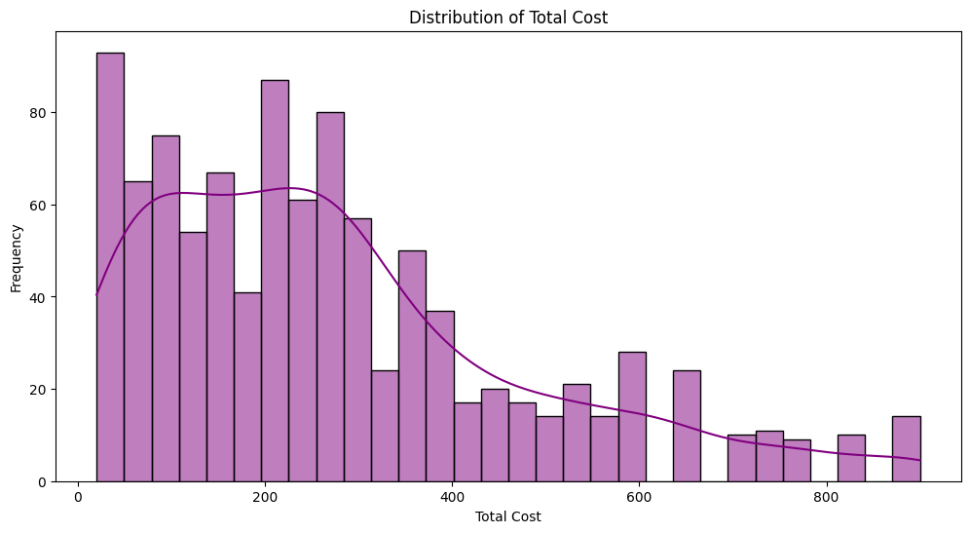

The analysis presents a visualization of the frequency of different menu items sold at various times of sale using a count plot. This type of chart provides insight into the distribution of sales over time and how specific items perform throughout the day.

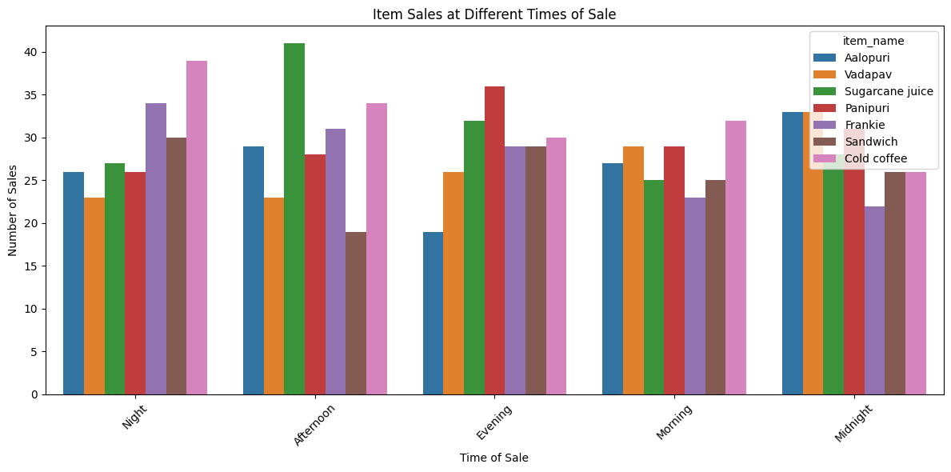

**Conclusion:**

Based on our analysis of both fast food and beverages, we recommend focusing on key items that show high sales potential. For fast food, sandwich, frankie, and panipuri are the top performers, while cold coffee and sugarcane are the standout beverages. To drive sales, we propose the following combo offers:

* Panipuri + Cold Coffee: 48
* Panipuri + Sugarcane: 36
* Frankie + Cold Coffee: 72
* Frankie + Sugarcane: 60
* Sandwich + Cold Coffee: 80
* Sandwich + Sugarcane: 68

These combinations are designed to appeal to customer preferences while offering a balanced price structure. The focus on in-place purchases highlights the importance of tailoring these deals to in-store customers to maximize revenue.